Google Glass……

Introduction:-
-Have you read about the google glass project and wondered what kind of apps you can build or design on glass?
-This seminar is designed to introduce developer and designer (and everyone else) to the google glass interface, the google mirror and the functionalities and limitation of both.
-Google is encouraging on ecosystem of developers and designed to build the apps that could make glass the next iPhone.

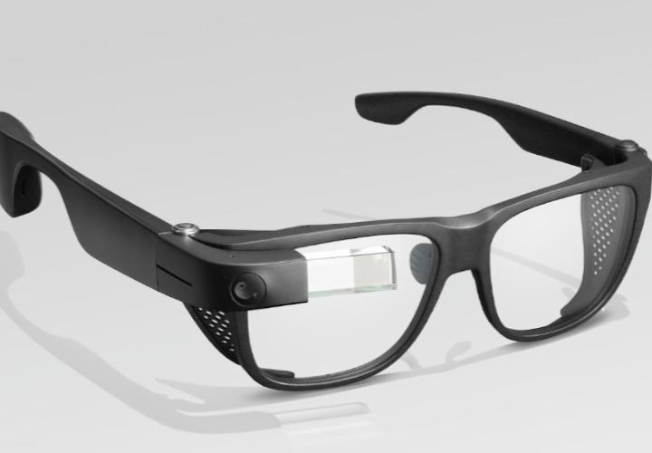

-It’s is glass with a smart phone in it.
-it’s brings the internet world and real world together.
-it has a microphone camera and a screen.
Highlights:-
-Also known as : Project glass
- developer : google
- Manufacture : Foxconn
- Type : Optical head mounted display(OHMD) , wearable technology
- Operating : Glass OS (4)
- CPU : OMAP4430 system on a clip, dual crore processor
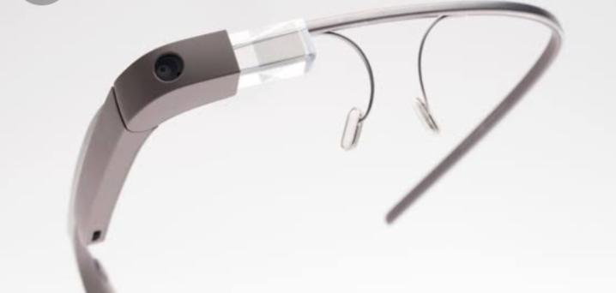
- Memory : 2GB RAM
- Storage : 16 GB of flash memory(12 GB of usual memory)
- display : prism projection, 640*360 pixels(equivalent to 25inch. 64mm screen)
- Sound : Bone conduction transducer
- Camera : 5 megapixel photos , 720P video
- Power : 570 MAH And Weight : 36g
Technology Used:-
-Wearable computing
-Smart clothing
-Eye tap technology
-Smart grid technology
-4g technology
-Android technology
-Ambient intelligence.
Wearable computing:-
Wearable computer, also known as body borne computers are miniature electronic devices that are worn by the bearer under, with on top of clothing.
Smart clothing:-
It is a combination of new fabric technology and digital technology, which means that the clothing is made with new signal – transfer fabric technology installed with digital devices.
Eye tap technology:-
An eye tap is a devices that is worn in front of the eye that acts as a camera to record the scene available to the eye as well as a display to superimpose a computer generate imagery on the original scene available to the eye.
Smart grid technology:-
A smart grid is an elected grid that uses information and communication technology together and act on information such as information about the behavior of supplies and consumers, in on automated fashion to improve the efficiency, reliability, economic and sustainablity of the production and distributiin of electricity.

4G technology
It’s a successor of the third generation (3G) standard. A 4G system provides mobile
Ultrabroadband internet access, For example-to laptops with USB Wireless modern , to mobile devices ,smart phones.

